Overview

This guide will assist you in navigating, registering and taking courses in the Learning Management System (LMS).

Table of Contents

The Learning Management portal
- What is Learning Management?
- Logging In to Learning Management
- The Learning Management Homepage

Learning Courses
- Starting a Course
- Overdue Learning Notifications
- Finding Courses
- Registering for a Course
- Registering for a Scheduled Course
- Reviewing Completed courses

The Learning Management Portal

What is the Learning Management Portal?

The Learning Management portal manages the entire learning process as you progress through each step including:
- Searching for items in a catalog in order to self-assign learning
- Assigning learning that displays on your Learning Plan/ To Do List
- Register for a scheduled course for instructor-led event
- Launching online learning tools for Self-paced training
- Recording learning history after completing a learning course
- Submitting feedback on evaluations

Logging in to Learning Management

Learning Management can be accessed through the following steps:

- Visit http://wbg.weill.cornell.edu
- Log in with your Cornell CWID and password

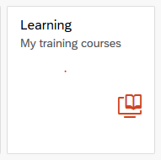
- Click the Learning tile
Note: Non-WCM Employees can access the Learning Management site by going to http://sf-lms.med.cornell.edu

The Learning Management Homepage

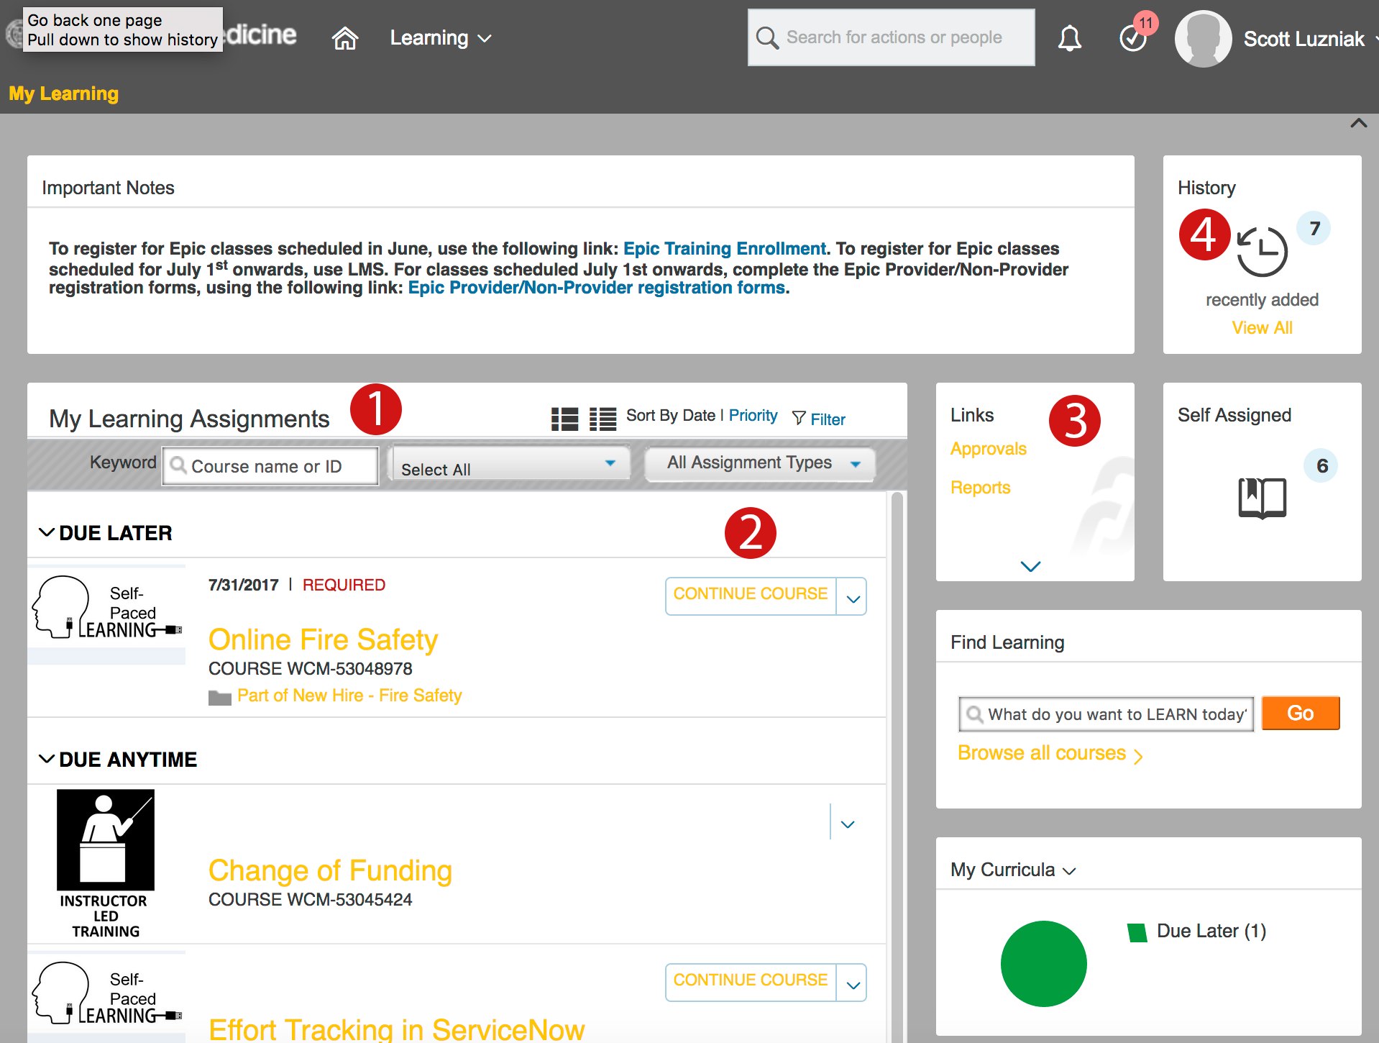

- My Learning Assignments: The My Learning Assignments tile displays your assigned learning activities. You can view your assignments and related details, launch training, and register for offerings.
- My Learning Assignment Actions: Every learning activity is listed with an action button and status update. You can show/ hide information, view the course start date and location for enrollment. These actions may include:
- Request Approval: Initiate an approval request via an automated workflow.
- Request Schedule: Request information on the availability and course schedule from the course owner.
- Start Course: Launch a course.
- Continue Course: Re-launch a course you have started.
- Register Now: Register for a course assigned to you.
- Remove Course: Remove a course that you have assigned to yourself.
- Links: Links to other learning and system features.

- Learning History: Searches for learning activities in the available catalog. Enter keywords in the text box to perform a quick search for related items in the catalog. Click Browse All Courses to navigate to the Learning Catalog.

Starting a Course

To start a course that you are registered for already follow the following steps:

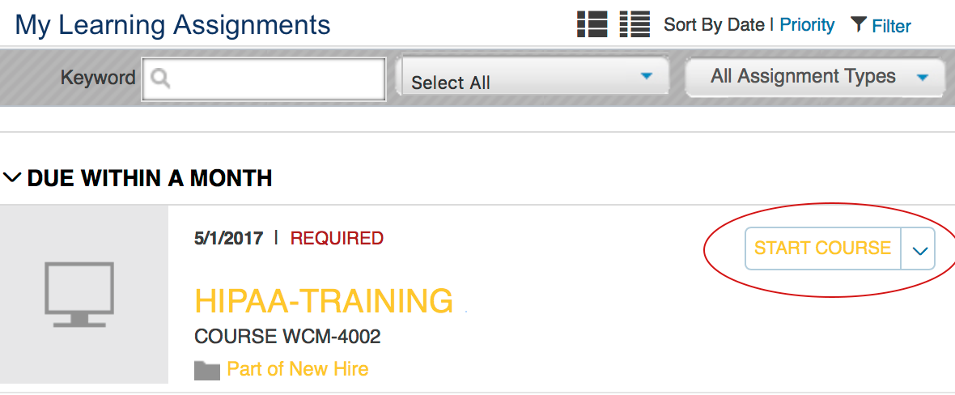

- From the My Learning Assignments section of the learning home page, find the course you would like to start and click Start Course from the drop-down menu.

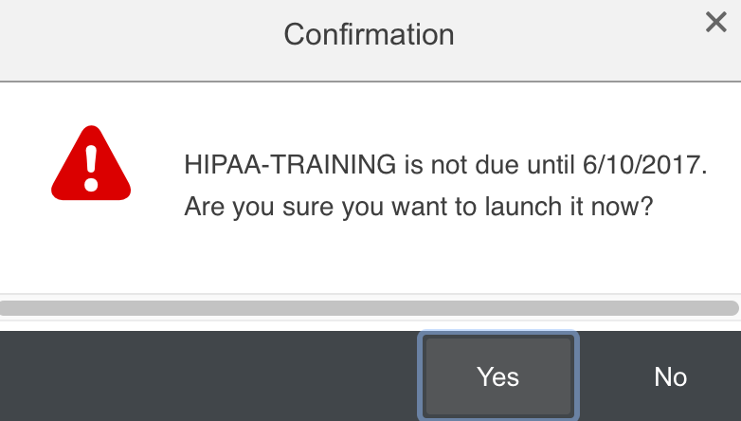

- If prompted for to confirm the start of a course click Yes.
- Click the link for the content you wish to start viewing.

Overdue Learning Notifications

In the event that you do not complete a course that you are assigned to within a certain period of time, you may receive an email notification from the Learning Management system to serve as reminder to complete your course.

Subject: LMS Overdue Learning Notification

Hello,
This note is to remind you of an overdue

Item (HIPAA-TRAINING) for Curriculum (New Hire) was due on 9/30/2016 11:59 PM America/New York .

Item (Online Fire Safety) was due on 3/1/2017 11:59 PM America/New York .

Check out our LMS help documentation here [Link].
This is a system generated message. You may receive additional notifications directly from a WCM training group.

This email will contain the course name and the date that completion due date. These emails are a reminder that you have learning courses that still need to complete.

Finding a Course

When you need to browse or search for a specific course that you wish to take use the Find Learning section of the My Learning homepage.

You can enter the name of the course you are looking for in the search bar, or you can click the Browse all courses link to look at all available courses in the learning system.

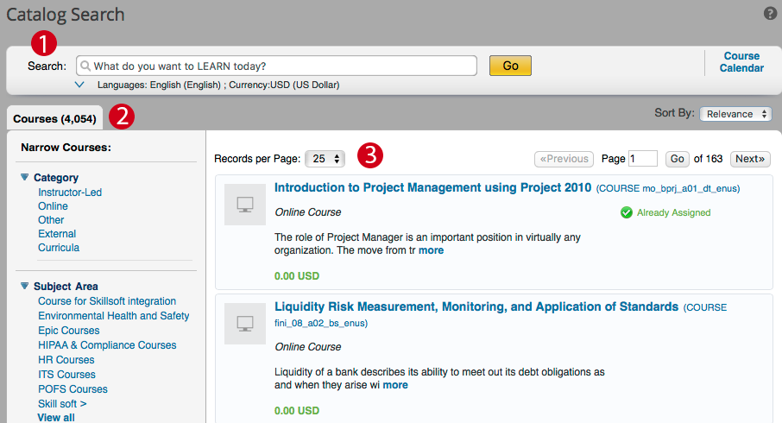

In the Library Search screen, you can locate the course(s) you wish to take in the 3 ways.

- Using the Search bar: Entering the course title that wish to take will allow you to find all courses with that name.
- Narrow Results Menu: Using the Menu on left hand you can Filter the displayed course by the following criteria:
- Category
- Subject Area
- Source
- Delivery Method
- Browse through the available courses through the main courses window.

To view more information about the course you wish to see click the title of the course.

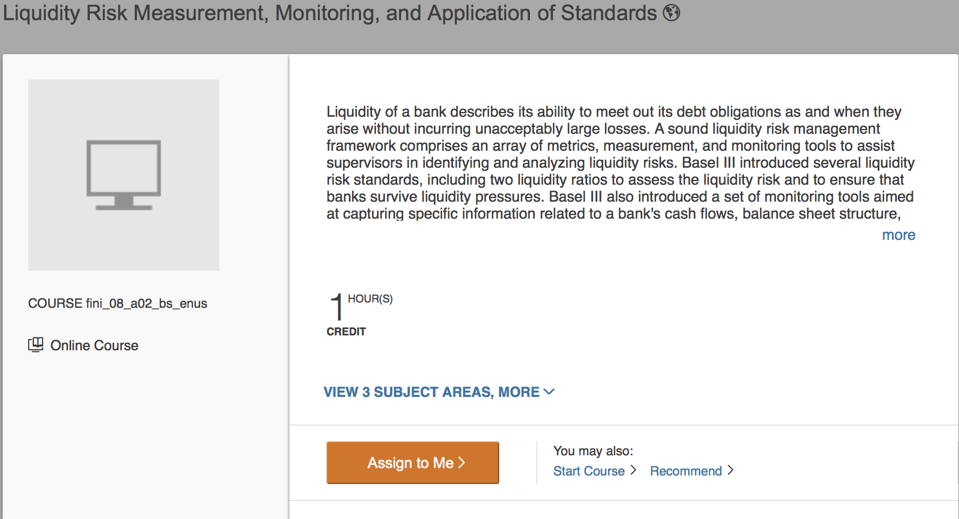

While viewing the course details you will see a description of the course, how many credit hours the course is, if applicable, as well as what subject areas the course will cover.

Registering for a Course

You can register for a course in following ways within the learning portal:

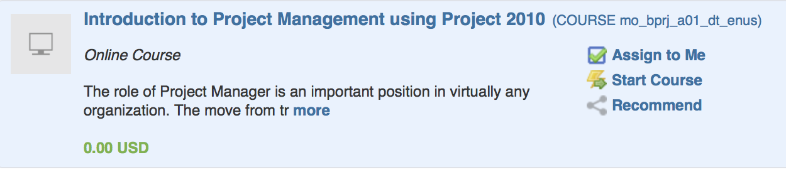

While in the course Search screen you can hover your mouse cursor over the course title section to see a menu where you can select Assign to Me.

While viewing the Course Details you can also click on the button Assign to Me.

Lastly, the course will be assigned to you if you click on the Start Course link in Course Details or from the Course Search Screen.

Registering for a Scheduled Course

Some courses that are in the Learning Catalog are Instructor Led Courses and are only available at Scheduled times.

To find these courses go to the Course Catalog Screen.

- Click the Course Calendar link to the right of the search bar.

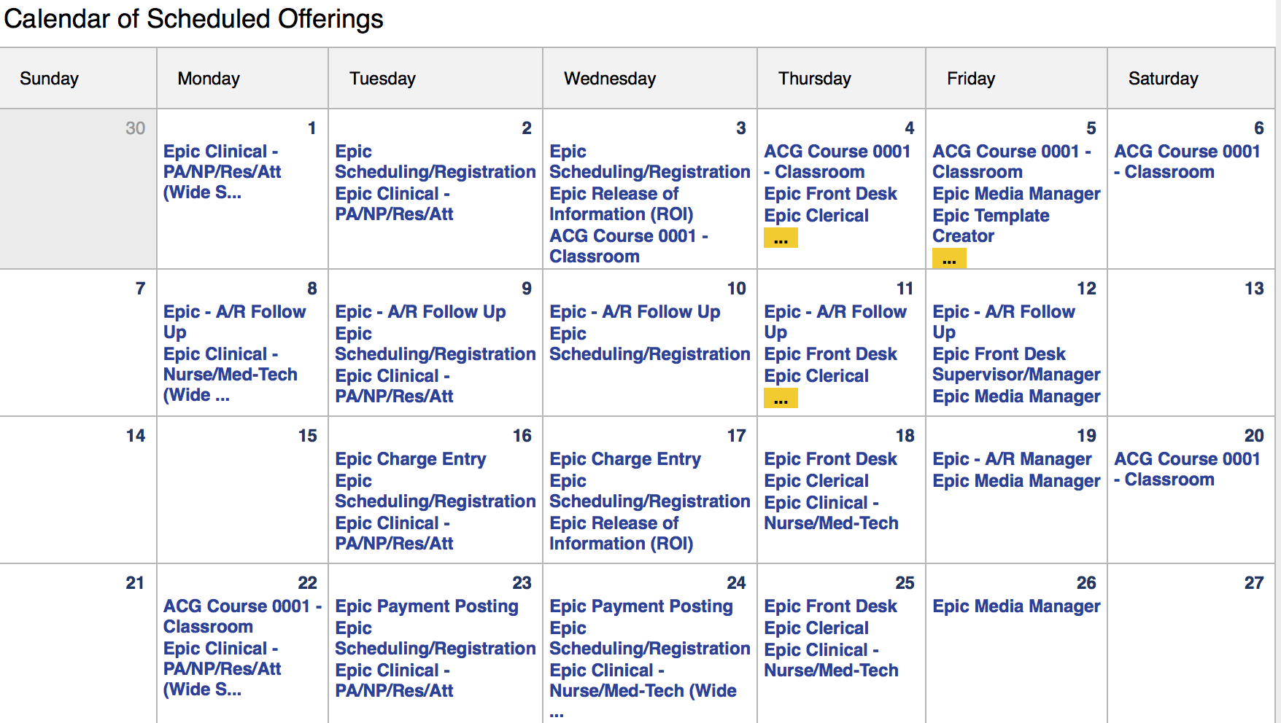

- Click the course title on the date you wish to register for.

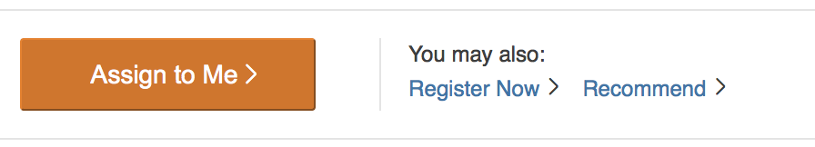

- Click the Register Now link to start the Registration process from the Course details screen.

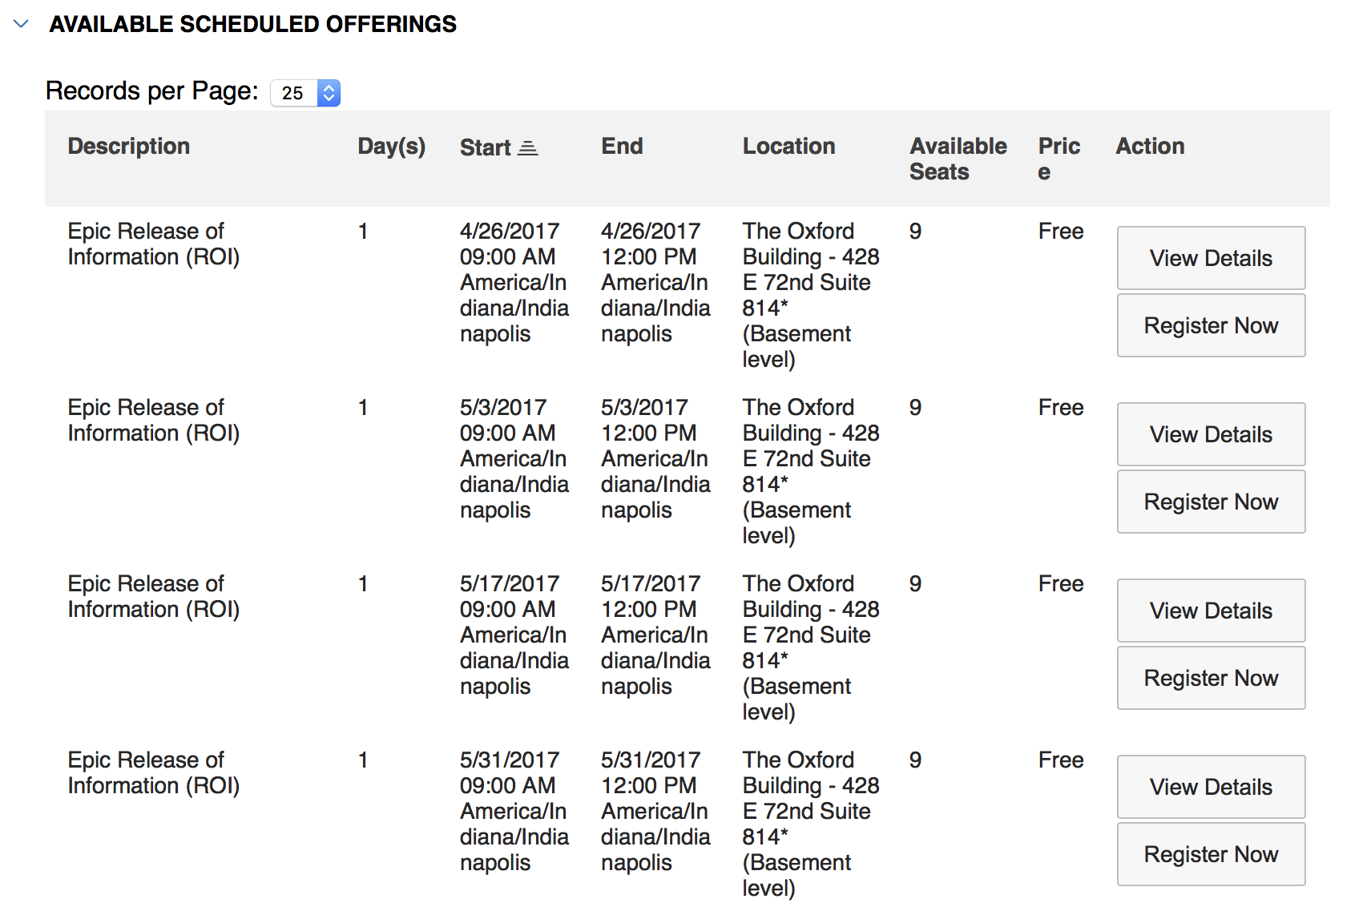

- Select the Register Now button for the Date and Time of the course you wish to attend.

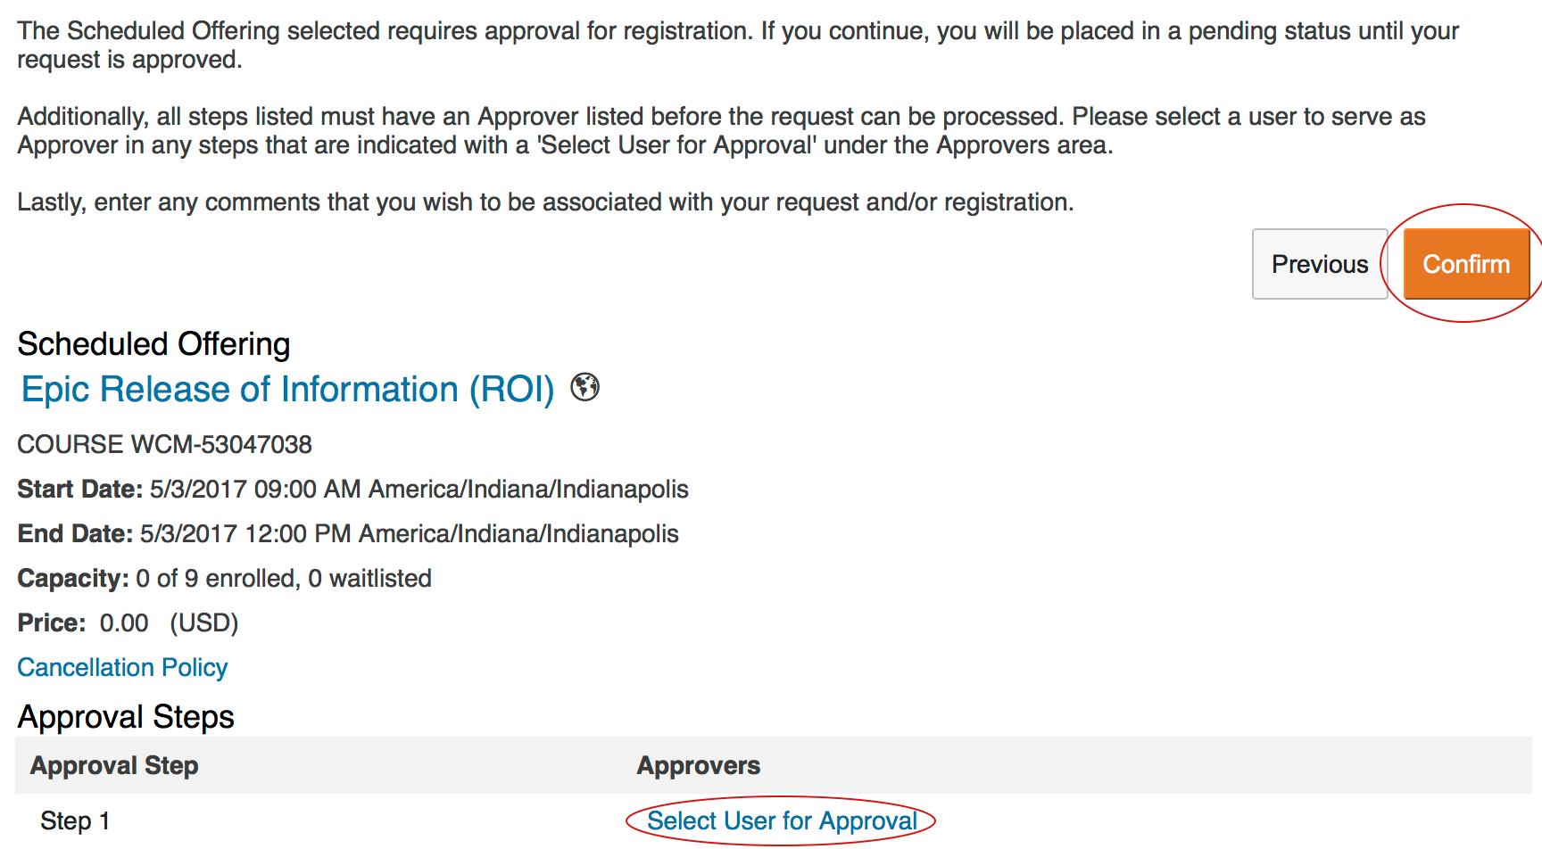

- Scheduled courses will require an approver listed to process your request. Click the link Select User for Approval and select the appropriate approver for your request.
- Once the approver has been selected click the Confirm button to process your request.

Reviewing Completed Courses

In order to view completed courses and to print any certificates you will need to go to the Completed Work Screen.

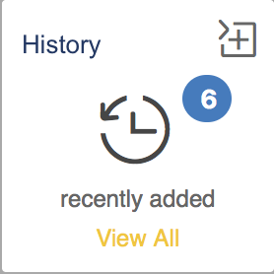

Click on the View All link from the History tile from the My Learning homepage.

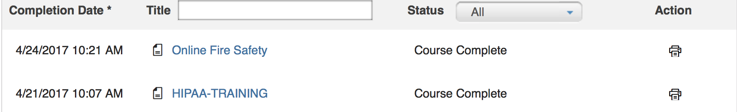

This screen will show you the completion date for your courses, course title, status of the course, and an option to print out any certificates or confirmation of course completion.

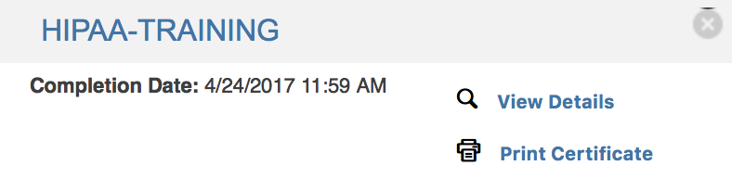
You can click on the title of the course and get the fly out window with options to view details of your course or to print certificate.

